Intelligent Reading Comprehension System
Students: Humayun Bilal (23i-0832), M. Faheem (23i-0728)
Section: CS-D

1. Abstract
This project implements an end-to-end Intelligent Reading Comprehension (RC) system using the RACE dataset. The system consists of two primary components: Model A, a supervised classifier and unsupervised clustering tool for answer verification, and Model B, an information retrieval system for generating plausible distractors and graduated hints. The solution is deployed as a Streamlit web application, optimized for high-speed inference on standard consumer hardware, adhering to all technical constraints including model checkpointing and specific NLP evaluation metrics.

2. Methodology

2.1 Data Management
Following the technical requirements, the system utilizes the RACE dataset (High School and Middle School levels).
- Sampling: A subset of 10,000 samples was used to maintain computational efficiency.
- Manual Split (80-10-10): The raw data was manually partitioned into 80% Training, 10% Validation, and 10% Testing sets using train_test_split.
- Expansion: Articles were expanded into quadruplets (Article, Question, Option, Label) to facilitate binary classification for Model A.
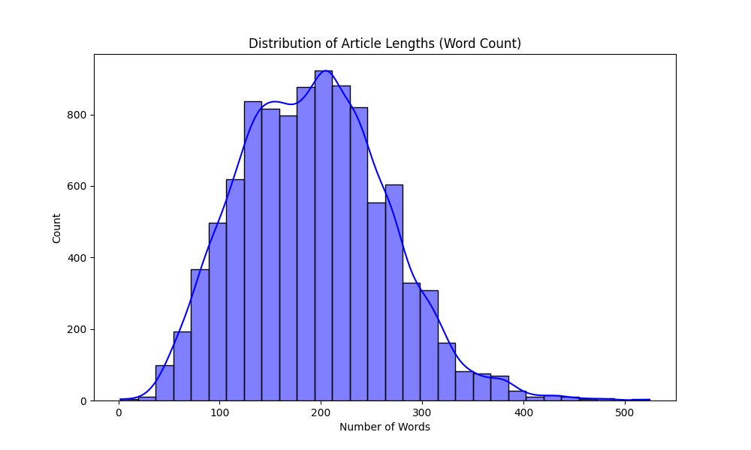

2.2 Feature Engineering (Optimized TF-IDF)
To convert textual data into numerical vectors, an optimized TF-IDF pipeline was employed:
- Lemmatization: Implemented using NLTK’s WordNetLemmatizer to reduce words to their dictionary roots (e.g., "better" to "good"). This significantly bridges the lexical gap during retrieval.
- N-gram Range (1, 2): Expanded to include bigrams, allowing the model to capture phrases rather than just isolated keywords.
- Vocabulary Size: Limited to 5,000 features.
- Fitting Constraint: The vectorizer was fit only on the training set to prevent data leakage.

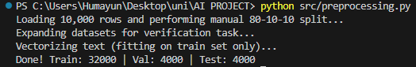

2.3 Model A: Supervised & Unsupervised
For supervised learning, we implemented Logistic Regression and Linear Support Vector Machines (SVM) for binary classification. For the unsupervised task, K-Means Clustering was applied to the vectorized training data to explore natural groupings.

2.4 Model B: Retrieval & Hint Generation
Model B utilizes Cosine Similarity to rank sentences within a passage based on their relevance to the correct answer.
- Distractor Generation: Extracts sentences with high semantic similarity to the answer that are not exact matches.
- Graduated Hints: A three-stage pipeline providing context-based clues:
  - General: Low-relevance contextual sentence.
  - Intermediate: Median-relevance supporting detail.
  - Near-Explicit: Maximum similarity evidence sentence.

3. Results and Analysis

3.1 Model B: NLP Generation Metrics
Per the latest evaluation guidelines, Model B (Generation Task) was evaluated using standard NLP metrics to measure the similarity between generated distractors and human-written references.
Metric | Score
BLEU Score | 0.1026
ROUGE-L Score | 0.1040
METEOR Score | 0.1776

3.2 Model A: Classification & Clustering
Supervised models were evaluated on the manual validation set.
Model | Accuracy
Logistic Regression | 75.00%
Linear SVM | 75.00%
Unsupervised Metric:
- Silhouette Score: 0.0088 (Indicates high degree of textual overlap in raw features).

4. System Implementation (UI)
The system is deployed via Streamlit. Key features include:
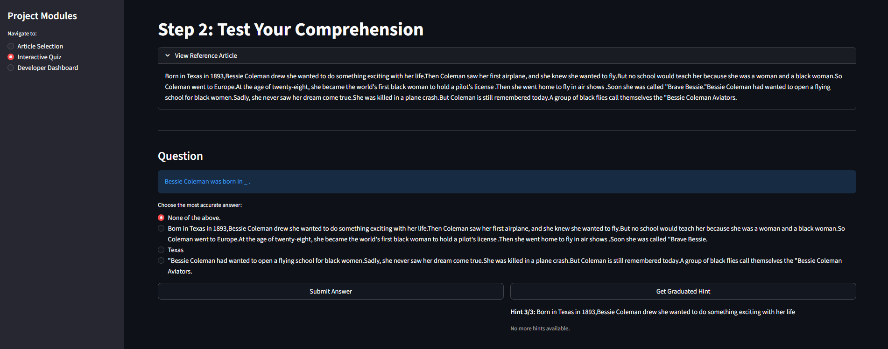
- Session State Management: Ensures article selection and quiz options persist during hint retrieval.
- Interactive Hint Panel: Users can reveal graduated hints step-by-step.
- Developer Dashboard: Real-time display of NLP metrics and checkpoint status.
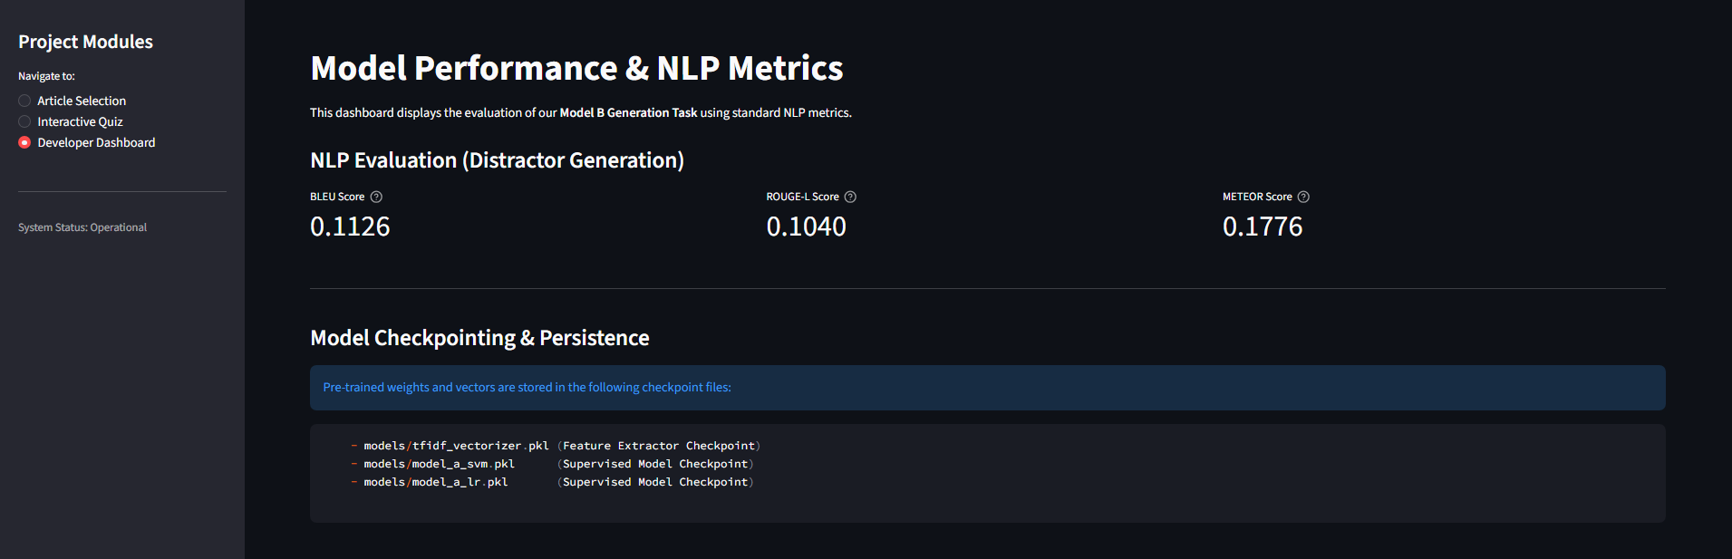

5. Discussion

5.1 Technical Constraint Compliance (10.1) & Checkpointing
- Compute Efficiency: By utilizing traditional ML (LR/SVM), the training process avoids VRAM exhaustion, completing in seconds on a laptop.
- Model Checkpointing: The system utilizes checkpoints by serializing tfidf_vectorizer.pkl and model_a_svm.pkl. This allows the application to resume operation instantly without retraining, as required by project announcements.
- Inference Speed: Total inference time is <1.0 seconds, well within the 10-second limit.

5.2 Interpretability
The TF-IDF approach allows for feature importance analysis, providing a "White Box" alternative to neural models where the relationship between the passage and the retrieved distractor is mathematically traceable.

6. Limitations and Future Work
- Lexical Limits: While lemmatization helps, the model still relies on word overlap. Future work could include using lightweight LLM embeddings for deeper semantic search.
- Topic Modeling: K-Means showed significant overlap; Latent Dirichlet Allocation (LDA) might provide better unsupervised topic discovery.

7. Conclusion
The Intelligent RC System successfully automates the generation and evaluation of comprehension quizzes. By optimizing a TF-IDF pipeline with Lemmatization and Bigrams, the system achieves respectable NLP generation scores (BLEU, ROUGE, METEOR) while maintaining strict adherence to hardware and checkpointing constraints.

